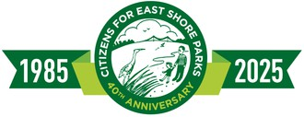

CITIZENS FOR EAST SHORE PARKS (CESP)
CONSERVATION IS AN INVESTMENT THAT DOES NOT LOSE ITS VALUE
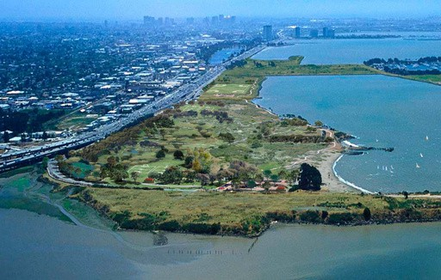
CESP Visioning for Future of Golden Gate Fields | Illustration by Steve Price.

Update on Golden Gate Fields
Robert Cheasty, CESP Executive Director

Friends,
April 2026

Magnificent news about Golden Gate Fields - the racetrack on the Albany-Berkeley shoreline is under contract for sale to Trust for Public Land, to be transferred to the East Bay Regional Park District. (Announced on March 31, 2026.)

It has been a decades-long vision of CESP to include this critical stretch of shoreline property into public parkland, providing major habitat, recreation, and wetland restoration. The closure of the racetrack in 2024 finally created such an opportunity.

Golden Gate Fields is 161 acres of the most fantastic shoreline in San Francisco Bay. Located in the middle of McLaughlin Eastshore State Park, the former racetrack would fill in the missing piece of park and open space along the shoreline. This is an opportunity of a lifetime!

Restoring this land would expand public access to the Bay, open up recreational opportunities, and protect sensitive habitat and wildlife. It secures the avenue for nature-based solutions to rising seas, acting as a buffer to protect existing infrastructure, such as freeways, as seas rise.

Citizens for East Shore Parks (CESP) | Mailing Address: P.O. Box 6087, Albany, CA 94706 Phone: (510) 524-5000 | Email: amaya@eastshorepark.org | Website: www.eastshorepark.org

Conserving our shoreline lands is a crucial part of addressing climate change along our coastal areas where we can enhance climate resilience using natural solutions. The former racetrack property is a prime property for that resilience.

This opportunity is the culmination of decades of collective effort. Our heartful thanks go out to the thousands of community members and organizations, who, for four decades, joined us in fighting for park and open space along our East Bay shoreline. You pushed back against large-scale development plans and passed zoning measures to protect the shoreline and keep it open to the public. It is this dedicated, collective effort – past and present – that has saved our shoreline.

There is much to do now to help complete this purchase. CESP will be reaching out to you for assistance with letters and calls to the state and the Park District to support the acquisition.

We have this monumental opportunity to green the east shore of San Francisco Bay from Crockett to San Jose and this racetrack property is a fantastic addition to the effort. One day, when we are built out from here to Reno, our great-great grandchildren will look back in awe and they will thank us for having the courage and wisdom to save the shoreline for them.

Here are links to a few of the many news outlets covering the plans for Golden Gate Fields and the announcement from Trust for Public Land: Berkeleyside | U.S. News & World Report | KQED | Trust for Public Land.

Sincerely,

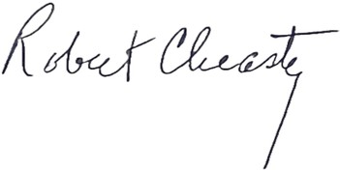
Robert Cheasty
CESP Executive Director

Citizens for East Shore Parks (CESP) | Mailing Address: P.O. Box 6087, Albany, CA 94706 Phone: (510) 524-5000 | Email: amaya@eastshorepark.org | Website: www.eastshorepark.org

