CITIZENS FOR EAST SHORE PARKS (CESP)

CONSERVATION IS AN INVESTMENT THAT DOES NOT LOSE ITS VALUE

Help CESP secure future parks & open space
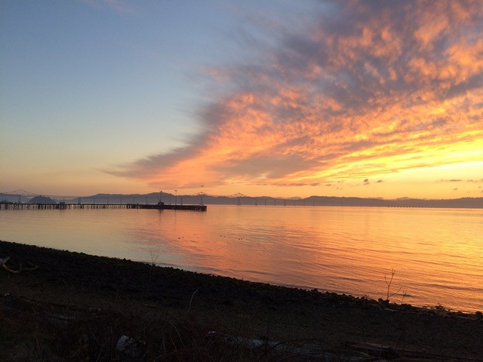
Pt Molate Sunset, Alix Mazuet

Dear Friends,
We have great news regarding Point Molate!! WE WON OUR APPEAL OVER POINT MOLATE!!
You will recall that after the prior City Council in Richmond approved a fatally flawed development proposal for Point Molate in 2020, Citizens for East Shore Parks (CESP) and other related organizations filed a California Environmental Quality Act (CEQA) lawsuit. We brought the action because of the multiple errors and shortcomings in the Subsequent Environmental Impact Report (SEIR) for the SunCal development planned for Point Molate. Unfortunately, the trial court was not favorable to our points and arguments and ruled against us.
But fortunately, the Court of Appeal was favorable when we appealed our loss. The Court of Appeal reversed the trial court decision and gave us a great victory – highlighting the flaws in the SEIR relating to protecting Ohlone Sacred Sites from destruction and relating to the lack of any proper plan for evacuation of Point Molate in the event of a wildfire. This was significant because Point Molate is recognized to be a high fire hazard zone.
Specifically, on November 27, 2023, the California Court of Appeal reversed a lower court decision and ruled that the Subsequent Environmental Impact Report (SEIR) for Point Molate must be decertified and related project approvals for Point Molate must be rescinded. The Court of Appeal sent the case back down to the trial court to implement these instructions and have the City comply.
While the decision of the Court of Appeal is more nuanced than the summary I just gave you, the important point is that the SEIR and related project approvals must be set aside.
Citizens for East Shore Parks (CESP) has been working to protect Point Molate against destructive development for over two decades. The Court of Appeal decision stops the proposed luxury housing development on Point Molate.
There are still many issues that we will need to work through, for example what roles will the City and the East Bay Regional Park District play and how will the City resolve its issues with various lawsuits, and how to separate the park issues from the Winehaven Village renovation issues.
But for now – this is an amazing time for us to celebrate. The really bad planning process of the former City Council has been stopped in its tracks. Good things can now be planned and implemented for Point Molate. The possibility of a beautiful regional park at Point Molate is one step closer.
If you have not been to Point Molate lately, take a short day trip out there - along the Richmond shoreline, just north of the Richmond San Rafael Bridge. Check out the shoreline ecosystems including sea hares, osprey and the amazing carbon-sequestering eelgrass — best in California — and honor the Ohlone land and its sacred spaces.
With sea rise, groundwater rise, and loss of biodiversity at our doorstep, every local action we can take collectively makes a difference in worldwide efforts to curb climate destruction. It takes a lot of work to protect shoreline open space for all to benefit.
We are grateful for you and the multiple community and environmental organizations and individuals who work with us to protect our environment.

Sincerely,
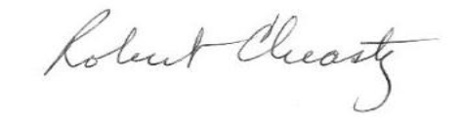
Robert Cheasty, CESP Executive Director

